Screenshots

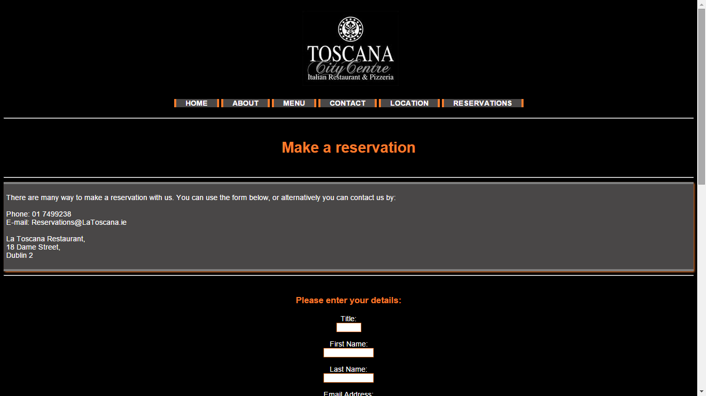Homepage.Html

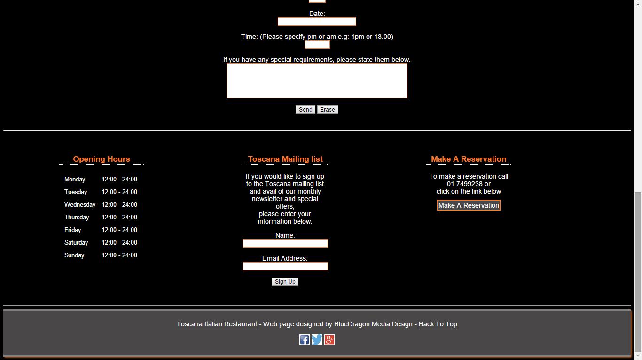

About.Html

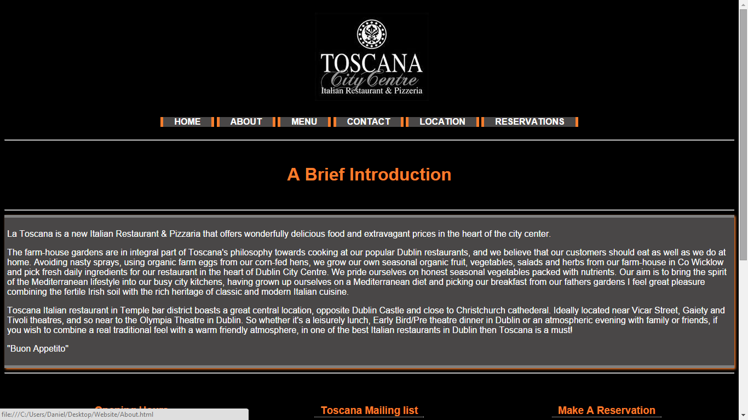

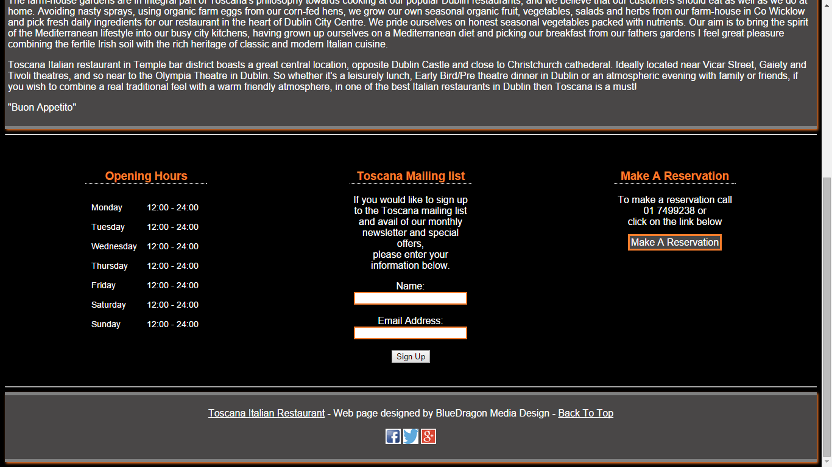

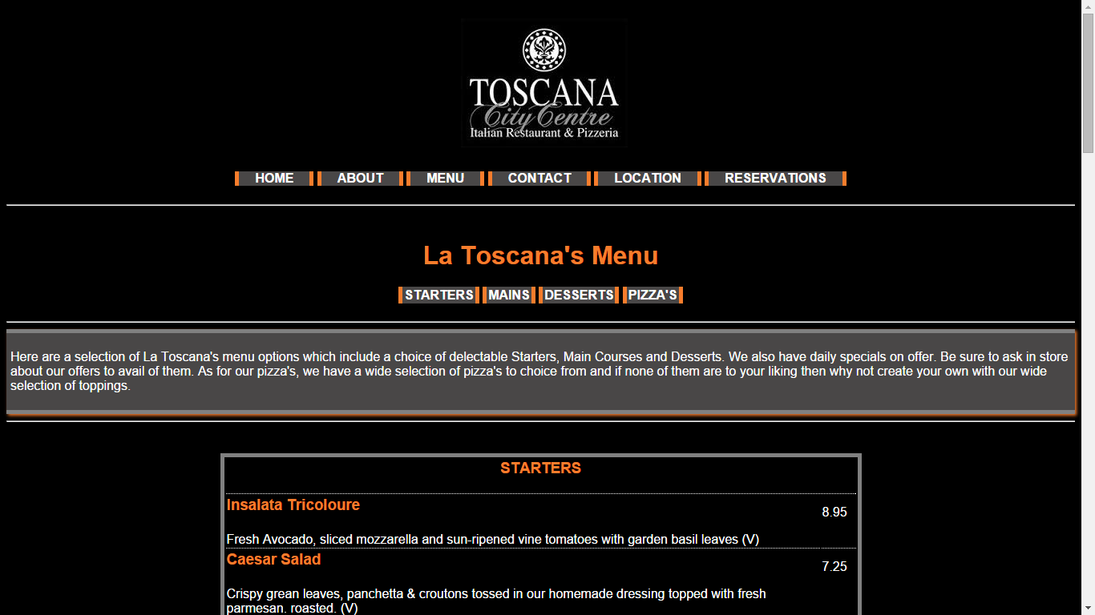Menu.Html

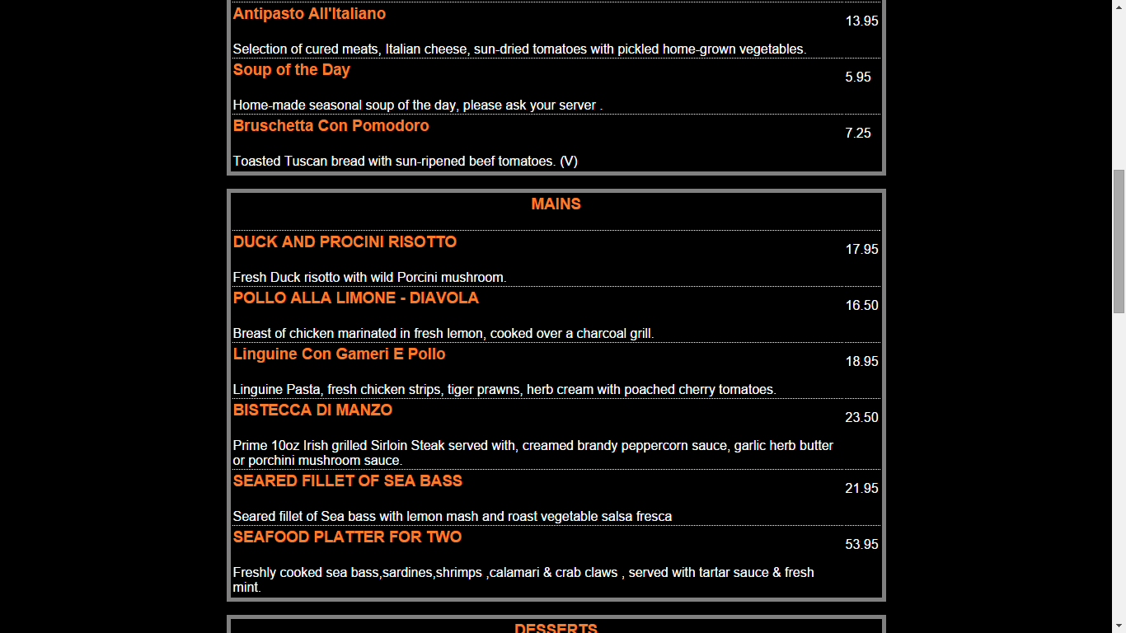

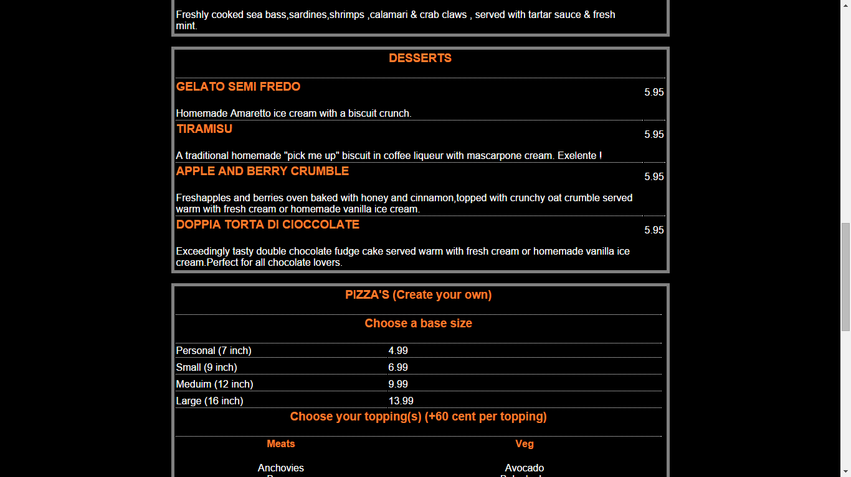

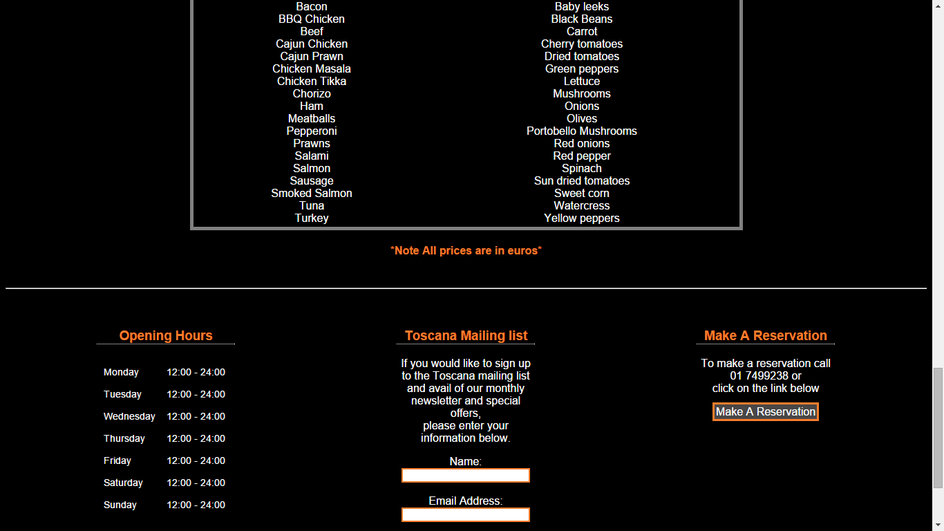

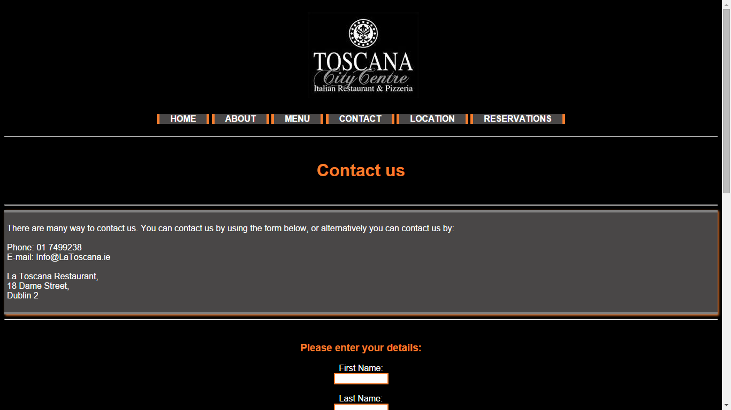Contact.Html

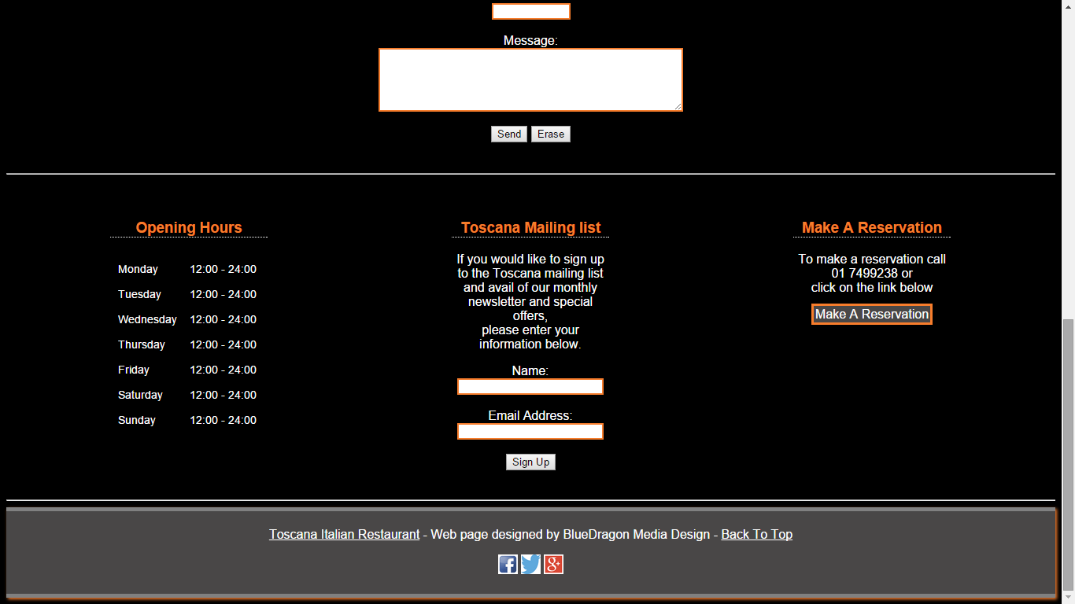

HowToGetThere.html

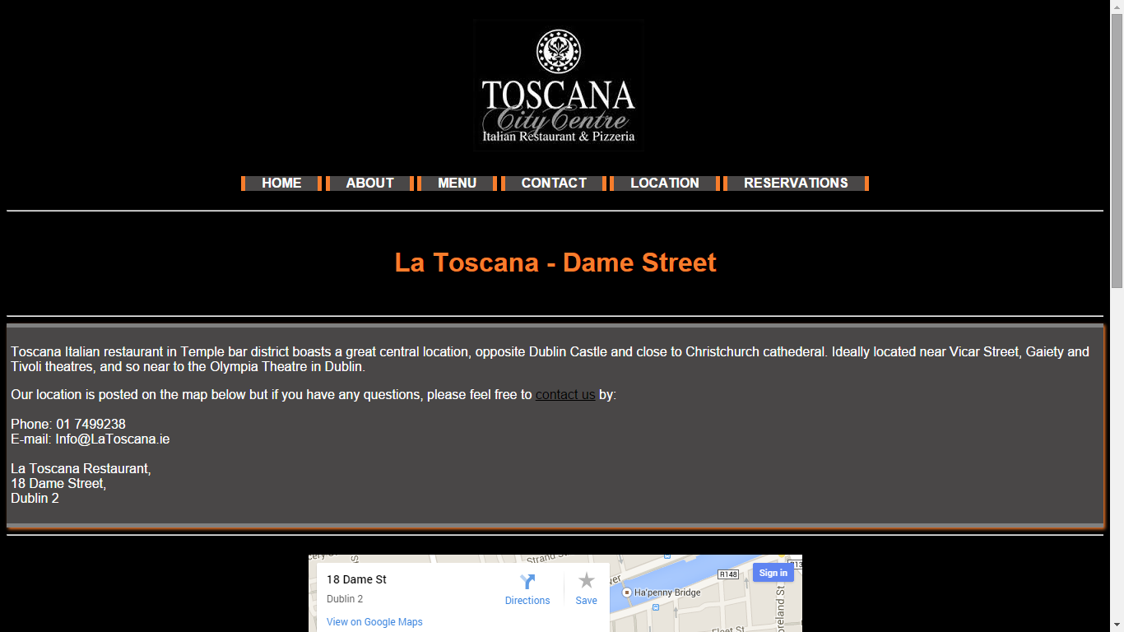

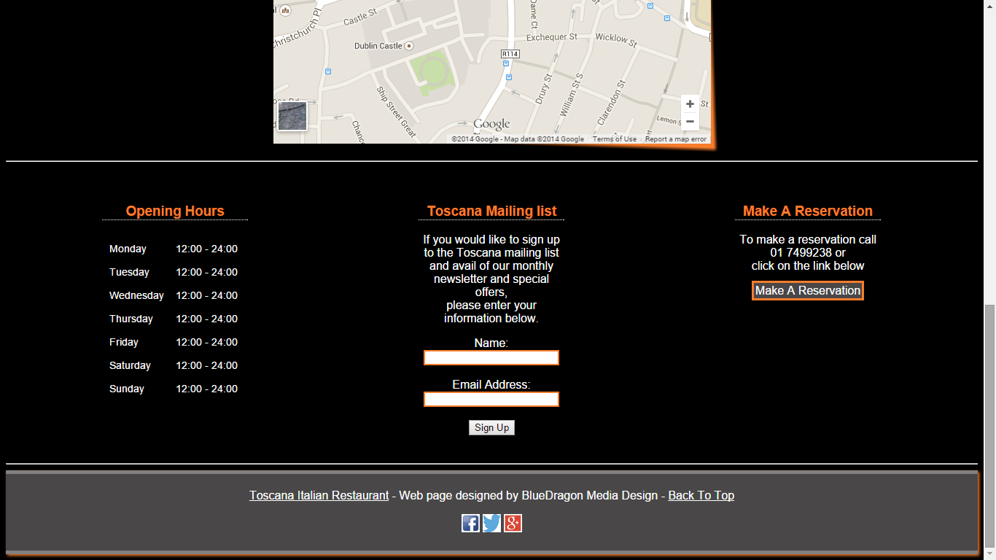

Reservations.html

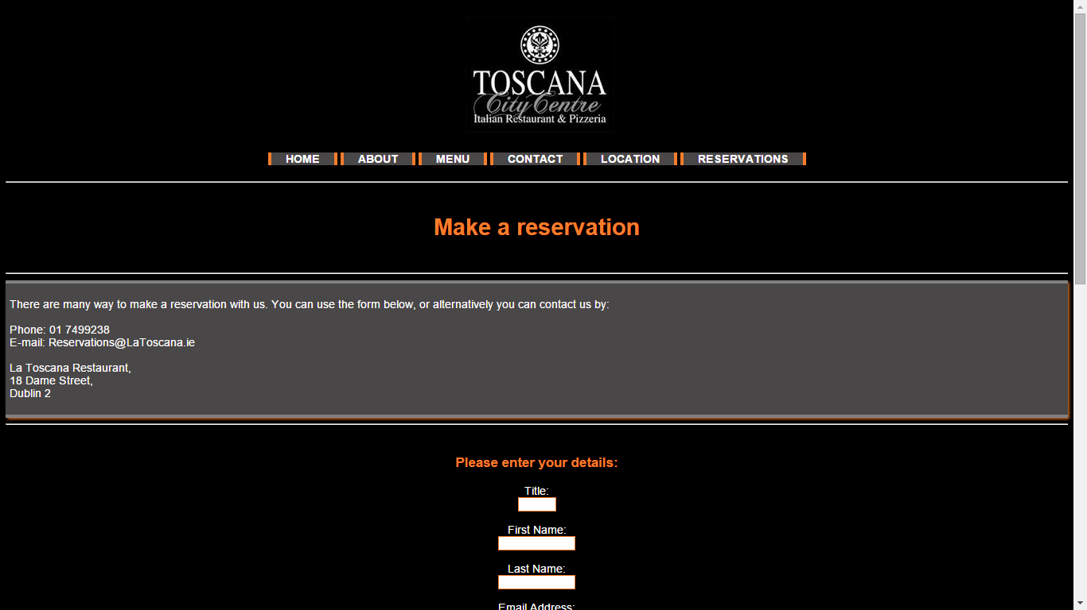

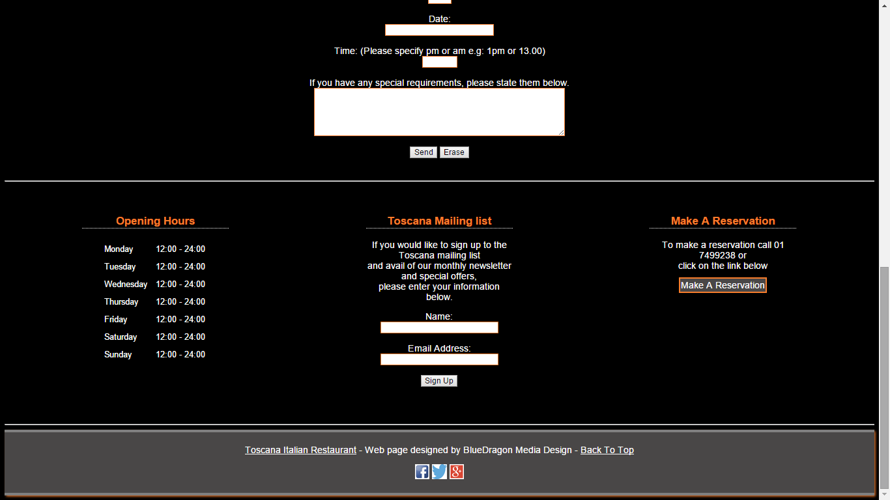

StoryBoard

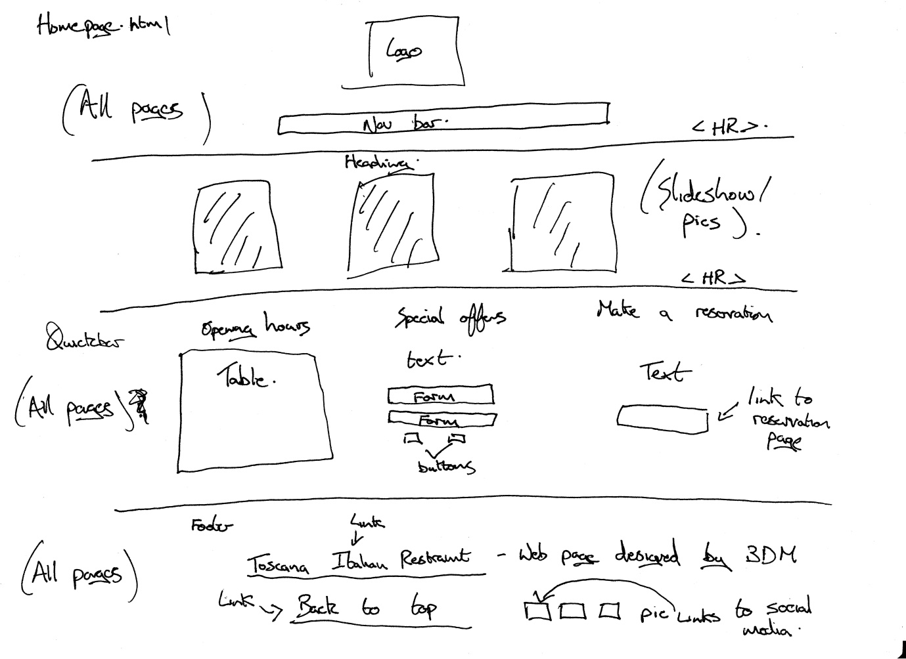Homepage.Html

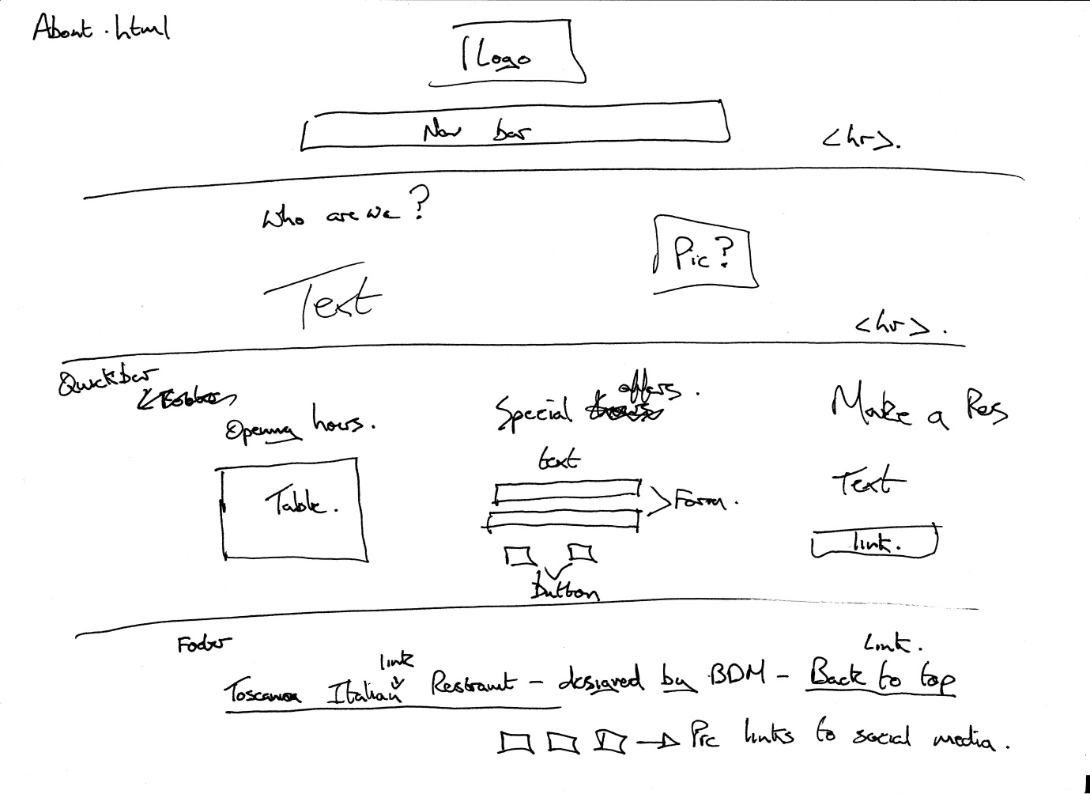About.Html

Contact.html

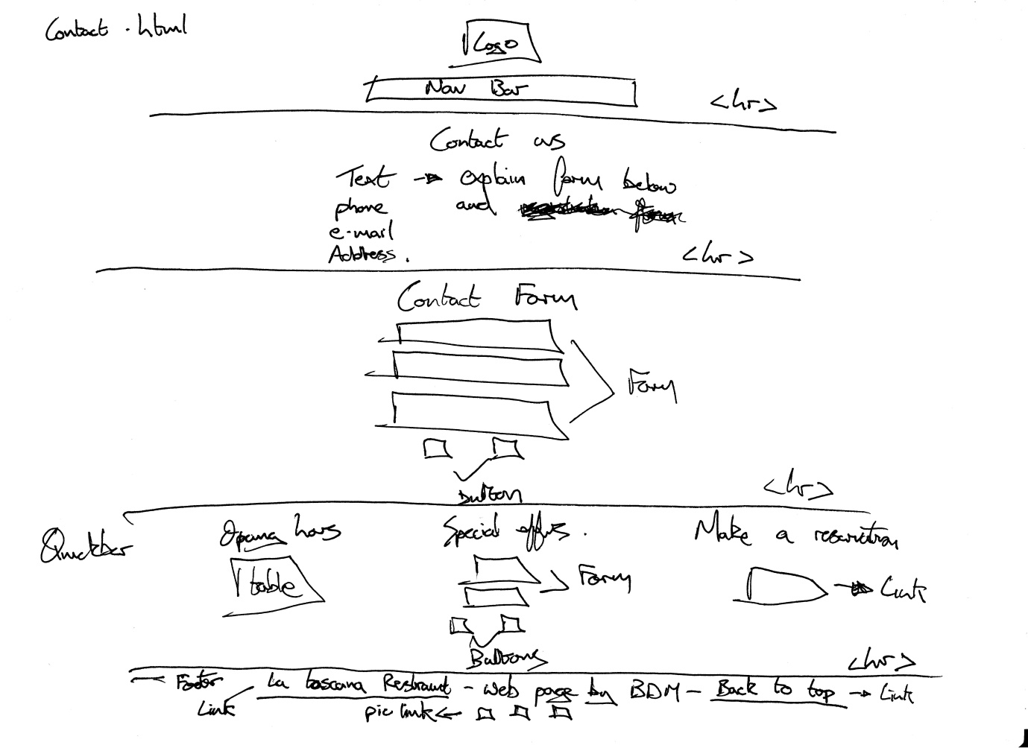

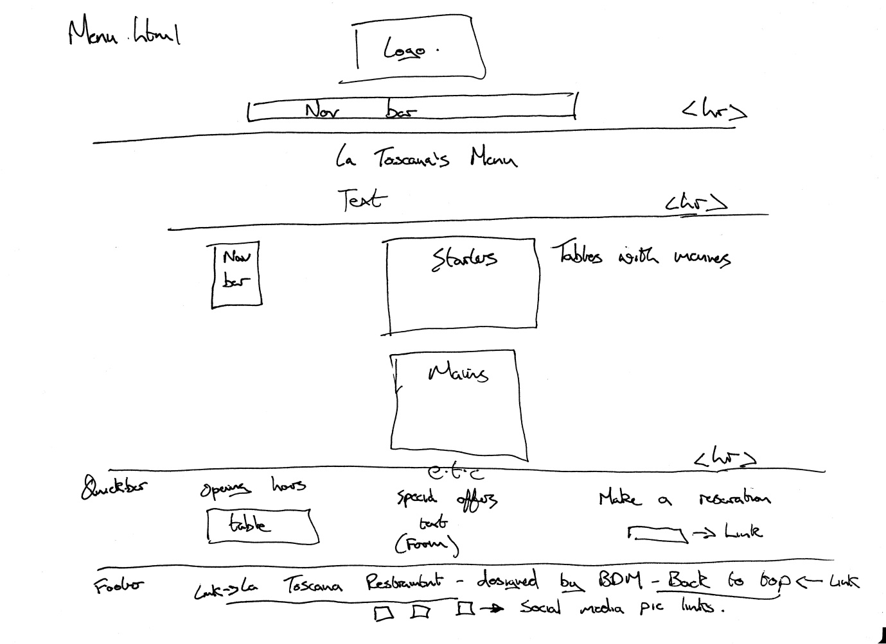Menus

Location.html

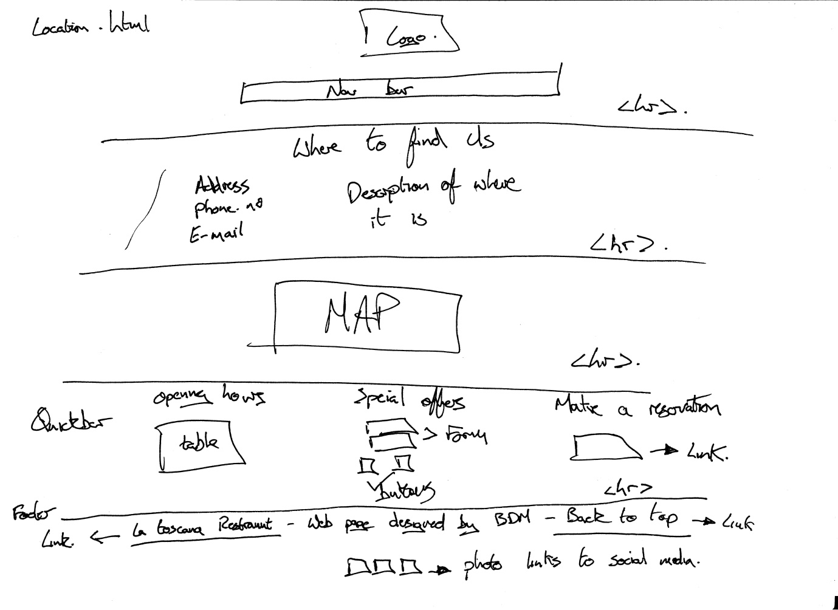

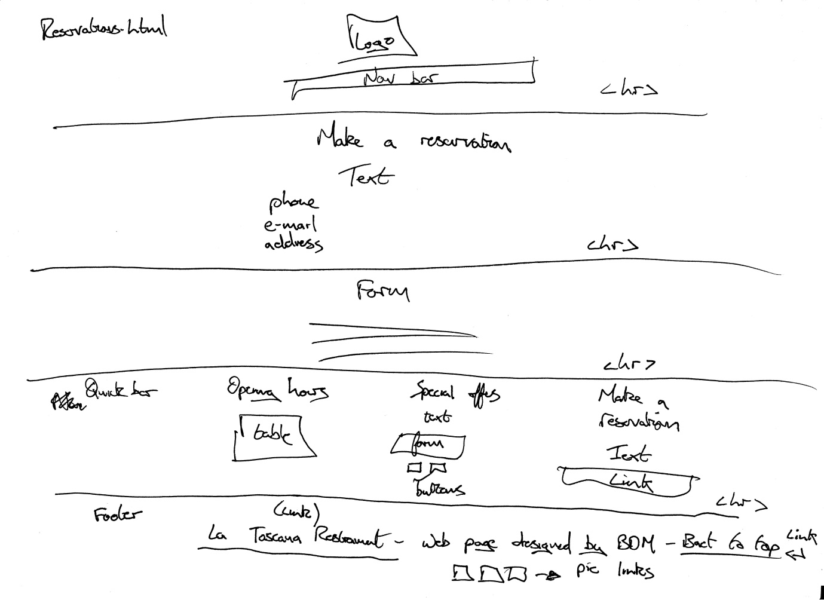Reservations.html

Nelsons Heuristics

Visibility of status: The webpage satisfies this because everything is very clearly laid out and easy to see and the user is constantly reminded about the status of the webpage.

Match to word: As there is no search bar on the webpage, this criteria does not need to be fulfilled.

User Control: The webpage satisfies this because there is a lot of user control on the page such as various nav bars and forms.

Consistency: The webpage satisfies this because there is a clear and constant layout amoung the whole website.

Errors Mgt: There is no need to manage any errors on the webpage as input is limited in the forms

Recognition: There is no need for users to login or create an account for this webpage so recognition is redundant

Simplicity: The webpage is very simple to navigate and is clearly laid out to the user.

Error Prevention: The forms limit the users input so they cannot input any wrong data

Help: There are various sections on the webpage that offer phone numbers and e-mail address if a user requires help